

**Contents**

**Executive Summary** 2

**Technical Report** 3

**Highlights of Project** 4

**Submitted on:** 4

**Abstract** 5

**Methodology** 6

**Results Section** 7

**Discussion** 11

**Conclusion** 11

**Contributions/References** 12

|  |
| --- |
| Executive SummaryExecutive Summary The "Global Wealth Distribution Analysis" report delves into the uneven distribution of wealth among various countries and continents. By analyzing data from multiple sources, it uncovers significant disparities in how wealth is distributed globally. The insights provided are vital for comprehending economic imbalances and offer valuable guidance to both policymakers and academic researchers. This brief overview highlights the importance of the study in informing discussions about achieving global economic fairness. | | |
| person at a table writing in a notebook with people around | | |
|  |  |  |

Technical Report

1. Top Countries with Highest GDP: The analysis commenced with the identification of countries boasting the highest GDP. Luxembourg emerged as the frontrunner, with a notable lead, while other nations demonstrated catching up trends. A particularly intriguing revelation was France's GDP, which stood at 2.5 times greater than the average of the world wealth.

2. Factors Affecting GDP: In-depth exploration was conducted to discern the primary factors influencing GDP. Scatter plots were employed to visualize the correlation between GDP and six selected columns. This step shed light on the nuanced relationships between these factors and a country's economic performance.

3. Model Visualization: To assess the predictive performance of the models, scatter plots were employed. The visualizations demonstrated a commendable alignment of model predictions with actual data, showcasing a reasonable and reliable model performance.

4. Total GDP Analysis: The study delved into the concept of total GDP by multiplying GDP per capita and population. This revealed the top 10 countries contributing to approximately two-thirds of the global GDP. A noteworthy finding was the disparity between countries with high total GDP and those with high average GDP.

5. Factors Affecting Total GDP: Correlation analysis unveiled that population and area played pivotal roles in influencing total GDP. These factors resonated with those identified in relation to GDP per capita, adding a layer of consistency to the overall findings.

6. Comparison of the Top 10 Countries: The economic structure of the top 10 countries with the highest total GDP was scrutinized. The analysis highlighted the significant impact of services and industry on their economies, providing valuable insights into the diverse economic landscapes of these influential nations.

In summary, the technical report's key findings underscored the complex interplay of factors shaping a country's economic standing. From the identification of leading GDP contributors to the exploration of nuanced correlations, the study significantly contributes to our understanding of global economic dynamics.

Highlights of Project

The "Global Wealth Disparity Analysis" initiative focused intently on mapping the pronounced variations in wealth accumulation around the world, thereby presenting an insightful view into the disparate states of economic health and inequality globally. This extensive project entailed a thorough comparative study of the economic status across a wide range of countries and continents. It went beyond merely assessing total wealth, delving into the distribution dynamics within these regions. This method provided essential insights into varying levels of economic inequality and overall prosperity.

The project's methodology was comprehensive and exacting. It involved a detailed gathering and analysis of wide-ranging datasets, which probably included data on economic metrics, demographics, and geographical aspects. The research team utilized advanced statistical techniques and visual representation tools for an effective interpretation of this data. Such a detailed approach was crucial in uncovering trends, anomalies, and significant patterns in wealth distribution worldwide. The outcomes of this research were enlightening and complex. A notable finding was the extreme imbalance in the distribution of wealth, evident both within individual nations and across continents. The analysis revealed that a minimal number of countries hold a majority of the world's wealth, whereas numerous other areas are markedly behind in terms of economic prosperity. This discrepancy not only illustrated the irregularities in economic development but also underscored its wider implications on global economic stability and growth.

Moreover, the study probed into the intricacies of how wealth is accumulated and distributed, shedding light on various factors that lead to economic disparities. It scrutinized the influence of political, social, and economic policies in forming wealth distribution patterns, offering a comprehensive perspective on how different nations handle and allocate their economic resources. The research also brought to light the role of historical, geographical, and cultural elements in shaping economic conditions.

## 

## Submitted On – 12/04/2023.

## Abstract

The project "Global Wealth Disparity Analysis" delves into the distribution of wealth among different nations and continents, leveraging extensive data encompassing economic, demographic, and geographical aspects. Through sophisticated statistical techniques and visual analyses, it reveals notable imbalances in how wealth is distributed globally, emphasizing the disproportionate concentration of wealth in certain countries contrasted with the economic underdevelopment in others. This research sheds light on the driving factors behind these disparities and their consequences for worldwide economic stability and policymaking.

Introductory Section

The "World Wealth Data Analysis" report's introductory section sets the stage by outlining the study's objective: to examine the distribution of wealth worldwide. Utilizing extensive data, the analysis seeks to reveal the variations and inequities in wealth among various nations and regions.

Github Repository Link - https://github.com/rashrana/World-Wealth-Data-Analysis

Review of available research

## Here we examine existing scholarly work on worldwide wealth distribution, highlighting significant research and perspectives that contribute to the understanding of economic inequalities between various nations and regions.

## 

## Methodology

## We elaborate on the methodologies and approaches employed for gathering and analyzing data. It encompasses acquiring data from various international sources, implementing sophisticated statistical techniques, and using analytical software to methodically explore and decipher patterns of wealth distribution among different countries and continents.

1. Data Collection: The World Bank collects and disseminates a wide range of data on various economic, social, and environmental indicators from countries around the world. The World Bank collaborates with other international organizations, such as the International Monetary Fund (IMF) and the United Nations (UN), to gather and validate data. The World Bank has an Open Data Initiative that aims to make its data freely available to the public.

2. Data Cleaning: We removed redundant entries and replaced missing or invalid values with the mean or median in the dataset. As part of the data transformation process, we converted attributes that were originally numerical but assigned as objects to numerical values. Additionally, new variables were created based on existing ones to render the data suitable for analysis.

3. Exploratory Data Analysis: To gain a broad understanding of the dataset and identify potential research inquiries, we conducted exploratory data analysis. We employed scatter plots, histograms, and descriptive statistics to examine the distribution of different variables and their interrelationships.

4. Modeling: We employed Linear Regression and Random Forest Regressor to assess the linearity and accurate classification of our data. Subsequently, we evaluated the model's precision using root mean squared error and mean squared log error.

5. Visualization: To communicate our findings and concepts to diverse audiences, we created a range of visuals. We employed bar charts, heatmaps, and scatterplots to illustrate the distribution, correlation, and connections among different variables.

6. Conclusion: Our analysis delved into the limitations and implications of our findings, leading to recommendations for future research. Additionally, our study identified the key factors influencing the country's economy based on our findings.

## Results Section

## In the "Result" section We present our empirical findings, initially focusing on descriptive statistics complemented by explanatory graphics for straightforward data visualization. Our approach advances testing hypotheses using methods like regression and categorical analysis. Additionally, we incorporate findings from diverse data mining techniques, presenting them in an accessible format with an emphasis on visual representation, yet ensuring the comprehensive presentation of statistical data.

## 

## 

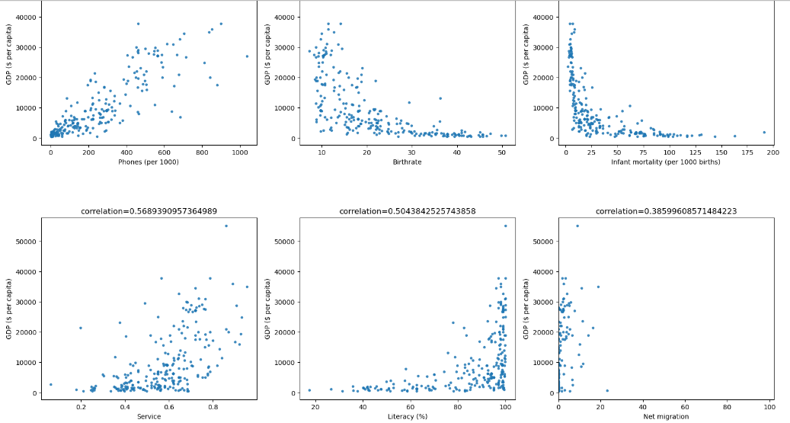

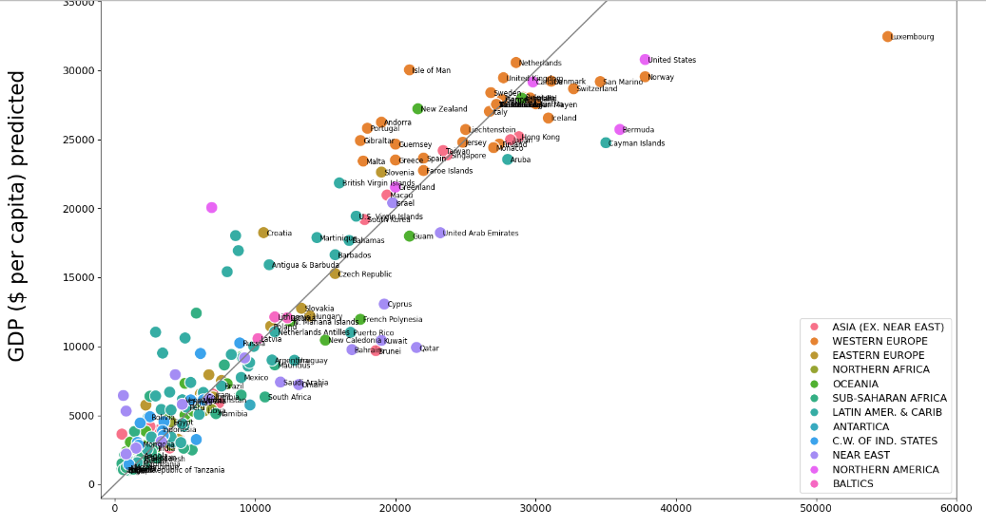

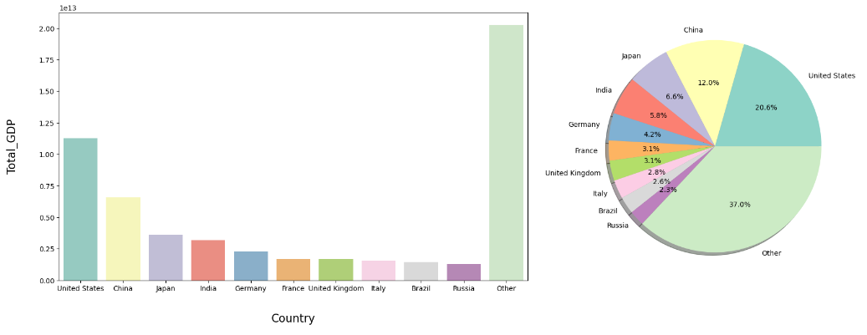

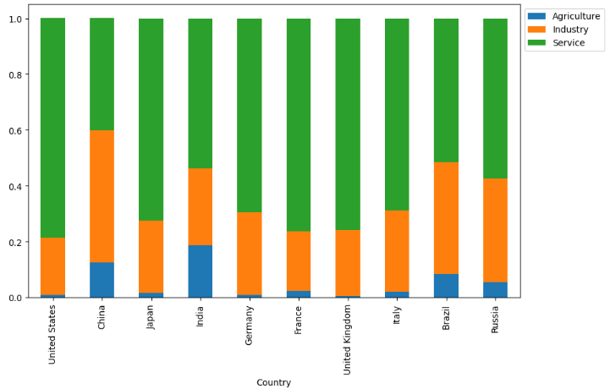

## Discussion

## In the "Discussion" section, we examine and interpret the gathered data, placing our findings within the larger context of worldwide wealth distribution. We relate these empirical outcomes to our original hypotheses, assessing how the results align with or challenge prevailing theories on global wealth inequalities. The discussion includes an exploration of the implications of our findings and acknowledges any limitations of the research, offering a thorough analysis of the results in relation to the broader field of economic studies.

## Conclusion

In the "conclusion" section, we encapsulate the key discoveries of our analysis concerning worldwide wealth distribution, underscoring the pronounced disparities revealed. We stress the importance of these insights in grasping global economic inequalities. Furthermore, we propose avenues for subsequent research that can extend our study's findings, delving deeper into the intricacies of global wealth distribution to aid in the development of more equitable economic strategies and measures.

Moving forward, it is recommended that future studies delve deeper into advanced modeling techniques and consider additional variables. Moreover, an exploration of specific economic policies that contribute to observed patterns could provide a more comprehensive understanding of the dynamics at play.

## Contributions/References

<https://www.credit-suisse.com/about-us-news/en/articles/news-and-expertise/credit-suisse-global-wealth-report-2022-fast-wealth-growth-in-times-of-uncertainty-202209.html>

<https://www.ubs.com/global/en/family-office-uhnw/reports/global-wealth-report-2023.html>

<https://www.visualcapitalist.com/distribution-of-global-wealth-chart/>

<https://www.kaggle.com/code/uzmatabassum/world-data2023#-Task-of-Analysis->